LEARNSYNC: A Cloud-Based AI Academic Assistant for Student Performance Development

A Capstone Project
Presented to the Faculty of the
COLLEGE OF INFORMATION TECHNOLOGY
CENTRAL BICOL STATE UNIVERSITY OF AGRICULTURE – SIPOCOT
Sipocot, Camarines Sur

In Partial Fulfillment of the Requirements
For the Degree of
BACHELOR OF SCIENCE IN INFORMATION TECHNOLOGY

MOHAMMAD HASSAN L. DE MESA
KRISSCEL A. MERENCIANO
LEA JEAN C. CAMAING

INTRODUCTION
Learning management systems have become essential in supporting the delivery of instructional materials, assessment activities, and student performance monitoring due to the increasing use of digital learning platforms in education. However, existing platforms may not fully address the specific academic and instructional needs of every educational institution. In response to these needs, LearnSync: A Cloud-Based AI Academic Assistant for Student Performance Development is proposed as an integrated platform for Governor Mariano Villafuerte Community College (GMVCC) that supports the management of learning materials, quizzes and activities, automated and manual score recording, student progress monitoring, and academic assistance based on teacher-uploaded learning materials.
University students often face challenges in balancing academic responsibilities with personal life, which can negatively affect their performance and focus. Issues such as heavy course loads, low academic standing, and lack of awareness of schedules or examinations contribute to difficulties in managing time and maintaining academic success. Hajamohideen et. al (2026). The integration of artificial intelligence (AI) into educational environments has opened new pathways for enhancing student learning and academic support. The cloud-based storage infrastructure allows students to access study resources anytime and anywhere, fostering a connected and inclusive learning environment. By embedding advanced AI technologies into the academic ecosystem, Smart Assist offers 24/7 support, helping students remain organized, manage academic responsibilities effectively, and ultimately improve their overall learning outcomes. Swetha et. al (2025).
This study will be conducted at Governor Mariano E. Villafuerte Community College (GMVCC), located in Potot, Libmanan, Camarines Sur. GMVCC is a public institution dedicated to providing free quality education, giving students the opportunity to pursue college degrees without tuition or other fees. For the Second Semester of Academic Year 2025–2026, the college recorded a total enrollment of 1,789 students across its programs. Specifically, the Bachelor of Technical-Vocational Teacher Education in Automotive Technology (BTVTED-AUTO) has 294 students, Electrical Technology (BTVTED-ELC) has 249 students, and Electronics Technology (BTVTED-ELX) has 336 students. The Bachelor of Science in Entrepreneurship (BS ENTREP) accounts for the largest group with 801 students, while the Bachelor of Science in Information Systems (BSIS) has 61 students, and the Associate in Computer Technology (ACT) program has 48 students. The primary client for this research is Ma’am Maricel R. Peneo, the school administrator of GMVCC, whose involvement ensures that the project aligns with the academic objectives of the institution and addresses the needs of both faculty and students. By situating the study within GMVCC, the research gains contextual relevance and contributes to the institution’s mission of fostering accessible, organized, and effective higher education for the local community.
Governor Mariano E. Villafuerte Community College (GMVCC) in Potot, Libmanan, Camarines Sur, despite its commitment to providing free quality education, continues to face challenges in effectively integrating technology into academic processes. The institution currently lacks a centralized system that can provide organized academic support and guidance to students. As a result, learners often struggle to access resources efficiently, leading to delays in retrieving important materials and difficulties in managing their study responsibilities. Instructional delivery is further hindered by the absence of a structured Learning Management System (LMS), which results in inconsistencies in course content distribution and limited opportunities for interactive learning. Teachers are burdened with manual recording and grading of assessments, a process that consumes significant time and effort while increasing the risk of errors. Additionally, the lack of a comprehensive data management system prevents the institution from systematically tracking and analyzing student performance. This gap delays timely interventions for struggling students and contributes to widening academic imbalances.
The researchers address the academic and technological challenges of Governor Mariano E. Villafuerte Community College (GMVCC) by introducing an integrated system equipped with a Learning Management System (LMS), a recording and grading sheet, and a data management framework. The proposed system will operate within the institution to provide organized academic support and streamline instructional delivery. The LMS will serve as a centralized platform where teachers can upload lesson modules, quizzes, and activities, ensuring consistent and accessible course content delivery. To reduce teacher workload and minimize errors, a recording and grading sheet will be developed to accommodate both automated and manual input assessments. Automated recording will cover online minor assessments such as quizzes and the scoring of asynchronous activities submitted in PDF format, while manual recording will include class participation, attendance, reporting, and recitations. Since grading systems vary across subjects, the sheet will also feature customizable grade percentages, allowing teachers to adjust weightings according to their specific requirements. Complementing these features, a data management system will be established to systematically track and analyze student outcomes, providing actionable insights for academic decision-making and performance monitoring. Collectively, these solutions aim to enhance student learning, reduce teacher workload, and promote efficiency in instructional delivery, thereby fostering a more effective and sustainable academic environment at GMVCC. The AI academic assistant of LearnSync will be powered by the Llama 3.3 70B model, an instruction-tuned large language model developed by Meta. The model is designed to understand user questions and generate relevant, clear, and contextual responses. In the proposed system, it will support students by providing academic assistance, guided explanations, question answering, and summaries based on relevant learning materials provided through LearnSync. The use of Llama 3.3 70B provides the system with a capable language model for handling complex academic queries and generating natural-language responses, supporting the goal of LearnSync to improve students’ access to academic assistance and learning support.

General Objectives
To develop and implement a comprehensive Learning Management System (LMS) that supports teaching, learning, and assessment processes.
Specific Objectives
- To develop an Assistant for academic guidance support for students and assessment generator for Teachers.
- To design LMS for delivering assessment and course content.
- To implement automated and manual assessment recording sheet for minor and major assessments.
- To track the student’s learning progress based on instructor’s sylabus.

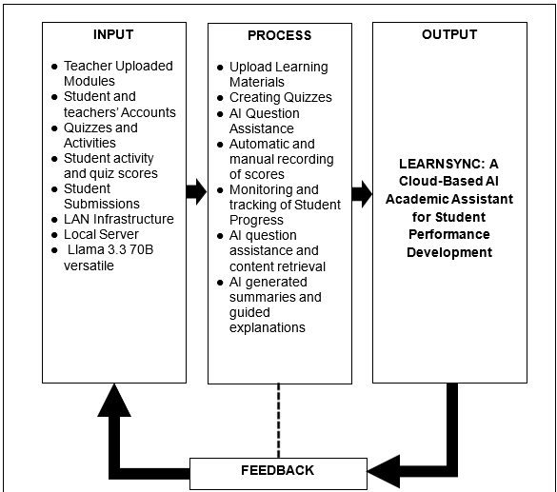

Figure 1
LEARNSYNC: A Cloud-Based AI Academic Assistant for Student Performance Development
The Input of LearnSync consists of the teacher-uploaded modules, quizzes and activities, student and teacher accounts, student submissions, quiz and activity scores, cloud infrastructure, and the Llama 3.3 70B Versatile AI model. These inputs provide the instructional content, user information, assessment data, and technical resources required for the operation of the system. The uploaded learning materials serve as the primary source of academic content, while student submissions and assessment scores provide information that can be used to monitor and evaluate student performance. The Llama 3.3 70B Versatile model supports the AI Academic Assistant in understanding questions and generating academic responses based on the relevant information provided by LearnSync.
The Process consists of the Learning Management System and the AI Academic Assistant. The LMS allows teachers to upload and manage learning materials, create quizzes and activities, record scores, and manage student learning resources. Students can access the available materials, answer quizzes, and submit their activities through the platform. The system records assessment results and student activities to support progress monitoring. Meanwhile, the AI Academic Assistant processes relevant teacher-provided learning content to assist students with academic questions, provide guided explanations, generate summaries, and retrieve relevant content. Through these processes, LearnSync integrates learning management and AI-assisted academic support into one platform.
The output of the system includes centralized access to learning materials, automated quiz scoring and manual score recording, student progress monitoring, AI-assisted learning support, and performance reports and analytics. These outputs allow GMVCC students to access their learning resources and receive academic assistance through the platform, while teachers can manage instructional materials, record assessment results, and monitor student progress. The performance reports and analytics can also provide teachers and administrators with organized information about student performance, which can support the identification of learning needs and improve the management of learning activities.
Scope and Delimitation
This study is limited to the Bachelor of Science in Entrepreneurship (BS Entrep) program at Governor Mariano E. Villafuerte Community College (GMVCC), located in Potot, Libmanan, Camarines Sur. The research centers on the development and implementation of an integrated academic support system designed to improve instructional delivery and streamline assessment processes within the program. By narrowing the focus to BS Entrepreneurship, the study ensures that the proposed system directly addresses the specific needs of students and faculty in this course, thereby enhancing its relevance and applicability. The scope of the project includes three major components a Learning Management System (LMS), a recording and grading sheet, and AI Assistance. The LMS will serve as a centralized platform for uploading modules, quizzes, and activities, ensuring that students have consistent access to course materials. To ensure standardization, lesson materials will be distributed in PDF format only, while written outputs can be submitted in Word format. The recording and grading sheet will accommodate both automated and manual input of student performance. However, the automated feature will be limited strictly to online quizzes, which will be checked and recorded automatically. Other forms of assessment such as face to face quizzes, class participation, attendance, reporting, and recitations will remain under manual recording. In addition, AI can also helps teachers by generating quizzes to be delivered to the students. To account for differences in grading practices across subjects, the sheet will also include customizable grade percentages, allowing instructors to adjust weightings according to their requirements.
This will provide instructors with actionable insights into student progress, enabling timely interventions and informed academic decision-making. Despite these advantages, the study is delimited in several ways. It will not extend to other programs offered at GMVCC, nor will it incorporate advanced predictive analytics or integration with external educational systems. As for quiz generation, teachers should review generated quizzes before delivering to the classes. Furthermore, automated checking will not cover asynchronous activities or other major assessments beyond online quizzes. Additionally, the AI assistant will generate responses strictly from the modules uploaded by the teacher, ensuring alignment with the approved instructional content.
Significant of the Study
The LearnSync system is expected to generate meaningful benefits to the following:
Teachers. Saves time and resources by centralizing module uploads, quiz creation, and student performance monitoring in one cloud-based platform.
Students. Ensures consistent access to lessons and activities, with AI assistance to support comprehension using teacher-provided materials.
Researcher. Enhances technical expertise and contributes new knowledge to educational technology.
Future Researchers. Serves as a reference for integrating cloud-based systems and AI in education, guiding future improvements and applications.

Definition of Terms
Learning Management System (LMS). A centralized digital platform used to deliver, manage, and monitor academic content such as modules, quizzes, and activities. In this study, the LMS serves as the backbone of instructional delivery for GMVCC’s BS Entrepreneurship program, ensuring consistent access to learning materials and assessments.
Artificial Intelligence (AI) Assistant. Known as a artificial intelligence assistant is a digital tool or application that uses generative AI technologies to perform tasks, answer questions, or execute commands. In this study, the AI assistant answers student queries and aids comprehension strictly and generates quizzes based on teacher-uploaded materials, ensuring curriculum alignment.
Cloud-Based Platform. Known as cloud computing, is a broad term for anything that involves the delivery of hosted services via the Internet. It supports flexibility, inclusivity, and efficiency in academic processes.
Recording and Grading Sheet . A digital tool that accommodates both automated and manual input of student performance. Automated features cover quizzes and minor assessments, while manual recording includes participation, attendance, reporting, and recitations. It also allows customizable grade percentages to fit subject-specific requirements.
Data Management Framework. A structured system for tracking, storing, and analyzing data. In this study, it provides instructors with actionable insights into student progress, enabling timely interventions and informed academic decision-making.
Progress Tracking. Monitoring progress toward a specific goal over time. In this study, it is used to track lesson progress based on class syllabus.

NOTES
Hajamohideen, F., Subramanian, K., Vimbi, V., Shafee, N., Al Mamari, R. Z., Al Mamari, M. A., & Al Balushi, N. M. (2026). AI-based digital academic assistance for supporting university students. In Innovations in management, technology, and performance (pp. 225–240). CRC Press. https://doi.org/10.1201/9781003778905-18

Swetha, C., Ismail, M., Anil, J., Venkatesh, K., & Rasheed, S. (2025). AI powered academic assistant using conversational AI. 2025 International Conference on Information Technology Trends https://doi.org/10.1109/ITT58520.2025.11012528

Healey, M. (2025). What is a learning management system (LMS)? Examples, types & pros/cons. Discovery Education. https://www.discoveryeducation.com/blog/educational-leadership/learning-management-system/

Kantor, A. (2026, January 15). AI assistant explained: Complete guide for 2026. The Business Dive. https://thebusinessdive.com/ai-assistant-explained

Unity Communications. (2025, May 26). What is a cloud-based system and how does it work? Unity Communications. https://unity-connect.com/our-resources/tech-insights/what-is-a-cloud-based-system-and-how-does-it-work/

Firican, G. (2025). Data management framework 101. LightsOnData. https://www.lightsondata.com/data-management-framework/

Alesforce. (n.d.). What is an AI assistant? https://www.salesforce.com/ap/agentforce/ai-assistant/ Salesforce.

Anderson C. (2024, September 6). What is progress tracking systems?
https://focuskeeper.co/glossary/what-is-progress-tracking-systems

CHAPTER II
REVIEW OF RELATED LITERATURE AND STUDIES
This chapter presents the review of related literature and studies collected from a range of credible references. It provides an organized discussion of existing works that are directly relevant to the topic, highlighting their contributions and insights. The review is arranged according to specific areas of concern, ensuring that each source is examined in relation to its relevance to the study.
AI Assistant
Artificial Intelligence (AI) and Knowledge Management (KM) are interconnected, with AI enabling machine learning and KM supporting knowledge sharing. A systematic review using PRISMA and PICO found that communication, trust, information systems, incentives, and organizational structure influence knowledge sharing. Integrating AI into KM enhances knowledge cycles, enterprise performance, and distribution, with leadership and organizational arrangements ensuring stability. The study, the first to examine KM with AI, calls for future research on smart assistant systems to strengthen competitiveness and deliver social benefits. Pai et.al (2021). Swetha et al. (2025) introduced Smart Assist, an AI-based academic assistant using NLP, machine learning, and cloud computing to provide secure, personalized student support with features like authenticated access, interactive chat, cloud storage, and 24/7 assistance. Built-in analytics enhance performance and organization, while AI integration has transformed Learning Management Systems (LMSs) through personalization and distance learning. A PRISMA-2020 bibliometric analysis shows rapid growth in AI-LMS research, led by authors such as Li J and Cavus N, with strong contributions from China and India. Despite advances in e-learning and emerging themes like learning styles and ontology, gaps remain in the effectiveness and acceptance of virtual assistants, highlighting the need for future research.
Learning Assistant Management and Builder (LAMB) is an open-source framework that integrates AI assistants into Learning Management Systems (LMS) while ensuring privacy, policy alignment, and reliable information use. Its modular design and features such as prompt engineering, retrieval-augmented generation, and knowledge base creation allow educators to build custom assistants without coding. Validated through the “Macroeconomics Study Coach,” LAMB has shown potential to enhance teaching, increase student engagement, and deliver personalized learning experiences. Its scalability, security, and open-source nature further promote collaboration and innovation in AI-driven education (Forment et al., 2025). Raghavendrachar et.al (2023) Developed AI-powered Learning Management System (LMS) for web development and coding, integrating a chatbot like ChatGPT to enhance learning efficiency. The LMS features document and video modules, step-by-step project guides, career roadmaps, and resources for problem solving and interview preparation. Its main goal is to evaluate how AI assistants accelerate skill acquisition, support app development, and improve learners’ employability. The paper assesses the effectiveness of each feature, offering a holistic view of how technology can streamline learning and career readiness.
The advent of Artificial Intelligence (AI) has transformed Learning Management Systems (LMSs), enabling personalization and distance education. Using PRISMA-2020, this study applies bibliometric analysis to examine AI integration in LMSs, revealing rapid growth with a 99.42% increase, especially in 2015 and 2021. Influential contributions include authors Li J and Cavus N, the journal Lecture Notes in Computer Science, and countries such as China and India. Thematic clusters highlight e-learning, ontology, and ant colony optimization, while emerging terms like Learning Style and LMS suggest areas for further study. Despite progress, gaps remain in the effectiveness and acceptance of virtual assistants, underscoring the need for a future research agenda. Celerina et.al (2025).
Learning Management System
The relationship between Learning Management System (LMS) usage and academic performance among 188 Filipino senior high school students. In today’s technology-driven education, institutions adopt ICTs, LMS platforms, and blended learning to improve student outcomes. However, findings based on the Pearson correlation coefficient revealed no significant relationship between LMS usage and academic performance. This highlights that while LMSs provide access and support, their effectiveness in directly influencing student achievement remains uncertain, pointing to the need for further investigation into how LMS integration impacts learning results. Tus et.al (2021). Technology has transformed education by moving beyond traditional classroom settings into interconnected, flexible learning environments. Modern learners increasingly reject rigid, stand-and-deliver approaches tied to fixed times and locations, favoring accessible, mobile, and personalized modes of participation. Advances in communication technologies and mobile devices have enabled learners to access knowledge remotely, while software vendors, open-source developers, and educational institutions have embraced systems that manage courses and engage students online. This shift highlights the growing importance of digital platforms in meeting the evolving demands of global education. Turnbul et.al(2020). The study of Rabiman et.al (2020) highlights the weaknesses of traditional learning, where educators and students face limitations in repeating material, note-taking, and access to knowledge restricted by time and space. With students increasingly dependent on digital content, online learning offers positive opportunities for accessible, storable, and shareable teaching materials. Using the Hannafin and Peck model (needs analysis, design, development, and implementation), researchers developed and tested an LMS-based e-learning system in a Mechanical Engineering Education microteaching class. Validated by experts and tested with 15 undergraduate students, the LMS was rated “very feasible” based on usability, functions, communication, design, and content. Findings show that LMS use improves satisfaction and learning quality, demonstrating its effectiveness in modern education.
The study of Obana (2021) Learning Management System: An Essential Tool to Enhance Remote Education. The Learning Management Systems (LMS) are essential in education and corporate learning because they provide flexible, accessible, and organized platforms for delivering online and blended learning. For students, LMS enables anytime, anywhere learning, allowing them to access courses, track progress, manage assignments, and interact with professors worldwide. Teachers benefit by uploading reusable materials, creating tests, giving real-time feedback, and monitoring student performance through analytics. A unique feature, multi-tenancy, allows schools to share resources while maintaining individual branding. In corporate settings, LMS supports employee development by tracking competencies and ensuring compliance, especially in regulated industries. Overall, LMS enhances efficiency, accessibility, and collaboration, making it a vital tool for modern education and workforce training. Rosario and Dias (2022) Indicates That the Learning Management System (LMS) is a vital tool in education as it manages, tracks, and delivers learning materials while organizing student records. Its adoption has revolutionized education by offering a comprehensive view of teaching, learning, and performance processes across students, teachers, and administrators. A systematic bibliometric literature review (LRSB) of 49 SCOPUS-indexed documents revealed the growth and innovations in LMS, identifying both opportunities and challenges in implementation. Findings emphasize that LMS designers and developers must understand the needs of different user groups to ensure tools and resources align with their expectations, ultimately improving student outcomes and learning quality.
Performance Monitoring
Educational Data Mining for Monitoring and Improving Academic Performance at University Levels, Educational Data Mining on 712 Moodle LMS logs from an African University to analyze student and staff usage patterns and their impact on academic performance. Data was processed using machine learning algorithms (clustering, classification, visualization) in WEKA, while SPSS correlation analysis examined links between course tool usage (Quiz, Assignment, Forum, Chat, Files, etc.) and final grades. Results showed significant correlations at the 0.01 level, indicating that higher engagement with LMS resources positively influenced student performance. Findings highlight the strategic value of LMS data for academic planning and improving learning outcomes. Okike and Mogorosi (2020). Costa et.al (2020) developed Monitoring Academic Performance Based on Learning Analytics and Ontology: A Systematic Review
the coordinated use of Learning Analytics and Computational Ontologies in evaluating student performance. From 1,230 studies, 31 were analyzed focusing on their use in describing Taxonomies of Educational Objectives and applying analytical models to educational data. Results show few studies connect LMS interactions to learning experiences, most use ontologies for learning object assessment and sequencing, and none report coordinated use for performance monitoring. The review concludes that future research should develop new models integrating both approaches to improve academic performance evaluation.
The study of academic performance monitoring system using least squares regression in MATLAB to predict student outcomes. A GUI was designed to forecast relationships between factors, with accuracy measured through Percentage Forecast Error (PFE) and Mean Absolute Percent Error (MAPE). The sample included 182 BS Information Technology students, with 13 selected via random sampling and their GPAs used for prediction. Results show the system effectively monitors and forecasts performance, supporting improved learning outcomes and academic planning. Pilarca(2023). The study developed of a web-based centralized tracking system for academic performance to address issues in traditional methods such as fragmented data, manual errors, and lack of real-time access. The system provides a unified platform for storing and managing student records, assessments, and progress reports, ensuring accessibility, scalability, and secure data handling. Findings highlight its role in enhancing transparency, identifying learning gaps, supporting outcome-based education, and generating analytical reports. Overall, web-based tracking systems modernize academic management and contribute to continuous quality improvement in higher education. Karper et.al (2025).
The limitations of Learning Management Systems (LMSs) in monitoring student progress and proposes the use of Learning Analytics with Student Performance Indicators (SPIs). Conducted at Cadi Ayyad University in Morocco, the case study tracked students in a Web Technologies course using SPIs to analyze instructional progress. Findings show that SPIs help faculty identify underperforming students, anticipate those at risk, and provide timely interventions. The research highlights that transforming LMS data into meaningful indicators enhances learner self-regulation, engagement, and academic support. Qazdar et.al (2023).
Automated & Manual Recording
Automated recording systems improve the efficiency and quality of documentation compared to manual recording methods. Their study explained that automated systems reduce the workload of employees because data are recorded automatically and accurately. On the other hand, manual recording requires more time and effort since information is written by hand. The researchers stated that automated systems help lessen documentation errors and improve record management. Tse et al. (2020).
The study of Minor et al. (2021) found that automated monitoring systems provide more accurate and consistent records than manual recording systems. The researchers explained that manual recording is more likely to contain incomplete or delayed information because it depends on human observation and manual input. The study concluded that automated systems improve the reliability of recorded data and support better monitoring processes.
The study conducted by Paulsen (2020) discussed the differences between manual data entry and automated form-processing technologies. The researchers explained that manual recording is reliable but requires more labor, time, and cost. Automated technologies such as Optical Mark Recognition (OMR) and Intelligent Character Recognition (ICR) improved efficiency and reduced the processing time of records. The study highlighted the importance of automation in managing large amounts of data effectively.
According to Henning et al. (2020), digital or automated record systems improve communication and make documentation faster during emergency situations. Their study found that manual recording methods were slower and more likely to miss important information during critical operations. The researchers concluded that automated systems provide better support in managing records during emergencies.
The study of Bansal and Sharma (2025) stated that automated school record management systems improve the speed and accuracy of processing student information compared to manual systems. The researchers found that automated systems were easier to use and more effective in organizing records. They recommended the use of automated systems in schools to improve record management and operational efficiency.
Progress Tracking
Shen et al. (2022) proposed a novel paradigm in Knowledge Tracing (KT) through the Learning Process-consistent Knowledge Tracing (LPKT) model, which emphasizes aligning students’ evolving knowledge states with their actual learning process rather than focusing solely on single interaction outcomes. LPKT integrates the positive effects of learning gains and the negative effects of forgetting to capture student progress across continuous learning interactions, thereby offering a more realistic representation of knowledge evolution. To account for individual differences, they extended the model to LPKT-S, which explicitly distinguishes each student’s progress rate. Experimental results on three public datasets showed that both LPKT and LPKT-S not only outperform state-of-the-art KT methods in predicting student performance but also provide knowledge states that are more consistent with the learning process, making them highly interpretable and accurate. This work highlights a promising direction for KT research by shifting focus toward continuous, process-consistent monitoring of student learning.
Starford and Ravlikj (2024) examined the efficacy of academic support interventions provided by the Swinburne College Student Hub for international students enrolled in the Postgraduate Qualifying Program (PQP) and English Language Intensive Courses for Overseas Students (ELICOS). Their study highlighted program-specific interventions, with PQP students receiving plagiarism checking, paraphrasing, proofreading, referencing, and essay structure guidance, while ELICOS students engaged in skill-based workshops targeting reading, listening, and writing. To refine these interventions, the researchers developed student progress trackers, which revealed significant improvements in assignment success rates and unit completion based on empirical data from 2022. Findings underscore the effectiveness of tailored academic support in enhancing student outcomes, with implications for improving the delivery of support services and strengthening academic performance among PQP and ELICOS cohorts.
According to Qazdar et al. (2022) they investigated the role of Learning Management Systems (LMS) in supporting student progress tracking during the COVID-19 pandemic, when digital learning platforms became central to higher education. While LMS platforms provide essential tools for managing courses and administration, the study noted their limited capacity to monitor instructional progress. To address this, the researchers applied learning analytics to define indicators capable of tracking students’ interactions with materials, identifying struggling learners, and highlighting those needing intervention. Using data from a Web Technologies course at Cadi Ayyad University, they developed student Key Performance Indicators (KPIs) that allowed monitoring of progress throughout the course. Although these indicators effectively tracked engagement and progress, they were less successful in determining overall student performance. The study underscores the importance of integrating analytics into LMS to enhance student success rates and improve the effectiveness of e-learning processes.
Yousufi et al. (2023) explored the application of Big Data Analytics (BDA) in education to enhance institutional decision-making and student progress tracking. Their study emphasized that analyzing large volumes of learner data enables institutions to identify success rates, achievements, weaknesses, and compare performance against benchmarked institutions for continuous improvement. Benchmarking was highlighted as a valuable tool for evaluating learners, faculty, and curriculum outcomes relative to similar programs. The research demonstrated that BDA can help decision makers detect, analyze, and predict educational progress, learner behavior, and course outcomes. Ultimately, the authors recommended effective implementation of BDA practices to monitor student performance, identify areas for improvement, and strengthen employability skills, underscoring its role in advancing academic success and institutional growth.
The study of Allam et al. (2023) investigated the use of machine learning algorithms to address challenges educators face in monitoring student academic progress and identifying at-risk learners. Their study emphasized that while institutions collect vast amounts of student data, leveraging this information through predictive models can enhance instructional quality and reputation. The proposed approach employed various machine learning techniques to create a model capable of detecting students at risk of failing, presenting results in accessible visual formats that allow teachers to implement timely interventions. By predicting learner behavior and course outcomes early, the model supports proactive support strategies and lays the groundwork for future predictive systems aimed at optimizing the overall learning process in higher education.
Synthesis of Related Literature and Studies
The reviewed literature collectively shows that the integration of Artificial Intelligence (AI), Learning Management Systems (LMS), knowledge management, and learning analytics is reshaping modern education by improving knowledge sharing, instructional delivery, and academic performance monitoring.
Several studies discuss the role of Artificial Intelligence in knowledge management and educational systems. Studies show that Artificial Intelligence enhances knowledge management and educational systems by improving knowledge sharing, communication, and organizational performance (Pai et al., 2021). AI-based tools like Smart Assist provide personalized learning through NLP, machine learning, secure access, and 24/7 support (Swetha et al., 2025). Frameworks such as LAMB enable the integration of AI assistants into LMS platforms with privacy and reliability (Forment et al., 2025). Additionally, AI-powered LMS platforms support coding education through chatbots, project guides, and career resources, improving student skills and employability (Raghavendrachar et al., 2023).
Research highlights that Learning Management Systems enable flexible, accessible, and organized digital learning environments (Turnbull et al., 2020). LMS platforms help manage learning materials, track student progress, and improve communication (Rosario and Dias, 2022). They also enhance usability, satisfaction, and learning quality (Rabiman et al., 2020). However, LMS usage does not always significantly impact academic performance, indicating the need for further improvement (Tus et al., 2021).
Literature shows that academic performance monitoring systems use data analytics and predictive models to track student progress and improve outcomes (Okike and Mogorosi, 2020). Learning analytics and ontologies support better evaluation of learning processes (Costa et al., 2020). Systems using regression models help predict performance and support planning (Pilarca, 2023), while centralized tracking systems improve transparency and data management (Karper et al., 2025). Student Performance Indicators also help identify at-risk students and enable early intervention (Qazdar et al., 2023).
For progress tracking, studies highlight the importance of continuous and AI-enhanced monitoring of student learning. Shen et al. (2022) introduced knowledge tracing models that capture learning as a continuous process, incorporating both learning gains and forgetting patterns. Similarly, Starford and Ravlikj (2024) and Yousufi et al. (2023) emphasized that progress tracking systems and big data analytics improve student monitoring, institutional decision-making, and academic support strategies. These studies demonstrate that combining analytics with LMS data significantly enhances educational outcomes.
The literature on automated and manual recording consistently shows the advantages of automation in education systems. Automated systems improve accuracy, reduce human error, and enhance efficiency compared to manual recording methods, which are often time-consuming and prone to inconsistencies (Tse et al., 2020; Paulsen, 2020; Bansal & Sharma, 2025). These findings support the transition toward digital record management systems in academic institutions.
NOTES
Pai, R. Y., Shetty, A., Shetty, A. D., Bhandary, R., Shetty, J., Nayak, S., Dinesh, T. K., & D'souza, K. J. (2021). Integrating artificial intelligence for knowledge management systems synergy among people and technology: A systematic review of the evidence. Economic Research-Ekonomska Istraživanja. https://www.tandfonline.com/doi/full/10.1080/1331677X.2022.2058976

Swetha, C., Ismail, M., Anil, J., Venkatesh, K., & Rasheed, S. (2025). AI powered academic assistant using conversational AI. International Conference on Advancements in Electrical, Electronics, Communication, Computing and Automation. https://ieeexplore.ieee.org/document/11012528

Alier Forment, M., Pereira, J., García-Peñalvo, F. J., & Casañ, M. J. (2025). LAMB: An open-source software framework to create artificial intelligence assistants deployed and integrated into learning management systems. Computer Standards & Interfaces, 92(4), 103940. https://www.researchgate.net/publication/386451753

Raghavendrachar, S., Anand, V. S., Anushree, H., & Manjunath, R. (2023). E-learning management system with AI assistance. International Journal for Research in Applied Science and Engineering Technology. https://elicit.com/review/fadce8c1 8904-4037-b4aa-34f331731562/source/ss-265299958

Celerina, B., Cabrera, C., Castillo Leal, M., & Silvestre, J. A. (2025). Artificial intelligence (AI) and learning management systems (LMS): A bibliometric analysis. Journal of Infrastructure Policy and https://www.researchgate.net/publication/388682559

Turnbull, D., Chugh, R., & Luck, J. (2020). Learning management systems: An overview. In Encyclopedia of Education and Information Technologies. Springer. https://link.springer.com/rwe/10.1007/978-3-030-10576-1_248

Turnbull, D., Chugh, R., & Luck, J. (2020). Learning management systems: An overview. In Encyclopedia of Education and Information Technologies. Springer. https://link.springer.com/rwe/10.1007/978-3-030-10576-1_248

Rabiman, R., Nurtanto, M., & Kholifah, N. (2020). Design and development e-learning system by learning management system (LMS) in vocational education. International Journal of Scientific & https://www.researchgate.net/publication/338594694

Tus, J., Cruz, M. A., Espiritu, N. A., & Paras, N. E. (2021). Amidst the online learning modality: The usage of learning management system (LMS) and its relationship to the academic performance of Filipino students. International Journal of Psychology and Behavioral Sciences. https://www.researchgate.net/publication/356912130

Obana, J. (2021). Learning management system: An essential tool to enhance remote education. Grant Thornton. https://www.grantthornton.com.ph/insights/articles and-updates1/from-where-we-sit/learning-management-system-an-essential-tool to-enhance-remote-education

Rosário, A. M., & Dias, J. (2022). Learning management systems in education: Research and challenges. Digital Active Methodologies for Educative Learning Management. https://www.researchgate.net/publication/361513255

Pkike, E., & Morogosi-Mpule, M. (2020). Educational data mining for monitoring and improving academic performance at university levels. International Journal of Advanced Computer Science https://www.researchgate.net/publication/347344808

Costa, L. A., Sanches, L. M. P., Amorim, R. J. R., Salvador, L. N., & Souza, M. V. S. (2020). Monitoring academic performance based on learning analytics and ontology: A systematic review. Central and Eastern European Online Library. https://www.ceeol.com/search/article-detail?id=896112

Pilarca, C. R., Opina, D. M., & Leuterio, J. S. (2025). Development of an academic performance monitoring system using least squares regression for predicting student academic performance status on professional courses. Journal of Innovative Technology https://www.researchgate.net/publication/380412960 Converge

Karpe, S., Thorve, A., Andhare, A., & More, D. (2025). A web-based centralized system for academic performance tracking. ASM Institute of Business Management and Research. https://www.researchgate.net/publication/395674410

Qazdar, A., Hasidi, O., Qassimi, S., & Abdelwahed, E. H. (2023). Newly proposed student performance indicators based on learning analytics for continuous monitoring in learning management systems. International Journal of Online & Biomedical Engineering, 19(11), 19. https://openurl.ebsco.com/EPDB%3Agcd%3A4%3A18306020/detailv2?sid=ebsc o%3Aplink%3Ascholar&id=ebsco%3Agcd%3A169957639&crl=c&link_origin=sch olar.google.com

Tse, M.-K., Li, S. Y. W., Chiu, T. H., Lau, C. W., Lam, K. M., & Cheng, C. P. B. (2020). Comparison of the effects of automated and manual record keeping on anesthetists’ monitoring performance: Randomized controlled simulation study. JMIR Human Factors, 7(2). https://research-repository.uwa.edu.au/en/publications/comparison-of-the-effects-of-automated-and-manual-record-keeping-

Minor, J., Smith, A., Deutsch, F., & Kellum, J. A. (2021). Automated versus manual urine output monitoring in the intensive care unit. Scientific Reports, 11(1). https://www.nature.com/articles/s41598-021-97026-8

Paulsen, A., Harboe, K., & Dalen, I. (2020). Data entry quality of manual double data entry and automated form processing technologies. Bergen Open Research Archive. https://bora.uib.no/bora-xmlui/handle/11250/2756372?locale-attribute=en

Henning, E., Bakir, M. S., Haralambiev, L., Kim, S., Schulz-Drost, S., Hinz, P., Kohlmann, T., Ekkernkamp, A., & Gümbel, D. (2020). Digital versus manual information management during mass casualty incidents at sea. PLOS ONE, 15(6). https://pmc.ncbi.nlm.nih.gov/articles/PMC7274416/

Ugalingan, N. M., & Antonio, E. O. (2025). Web-based school record management system: A comparative study of automated and manual recording methods. Aloysian Publications Journal. https://journals.aloysianpublications.com/index.php/articles/article/download/102/55/196

Shen, S., Chen, Z., Wang, Y., & Ding, W. (2022). Monitoring student progress for learning process-consistent knowledge tracing. 2022 IEEE International Conference on Data Mining (ICDM), 1190–1195. IEEE. https://doi.org/10.1109/ICDM54844.2022.00150 (doi.org in Bing)

Starford, A., & Ravlikj, I. (2024). Innovative progress tracking: Enhancing student achievement with effective interventions. TESOL in Context, 33(1), 1–15. Informit. https://search.informit.org/doi/abs/10.3316/informit.T2024072200005490390770421

Qazdar, A., Qassimi, S., Hassidi, O., Hafidi, M., Abdelwahed, E. H., & Melk, Y. (2022). Learning analytics for tracking student progress in LMS (Version 1). Research Square. https://doi.org/10.21203/rs.3.rs-1505417/v1

Yousufi, A., Naidu, V. R., Jesrani, K., & Dattana, V. (2023). Tracking students’ progress using big data analytics to enhance student’s employability: A review. SHS Web of Conferences, 158, 01003. EDP Sciences. https://doi.org/10.1051/shsconf/202315801003

Allam, H., Khan, Z., Letsholo, K. J., Pandya, B., Shah, K. A., & Ahamed, J. (2023). A proposed AI method for tracking college students’ academic progress. 2023 Information Technology Trends (ITT). https://doi.org/10.1109/ITT58520.2023.10184256

CHAPTER III
METHODOLOGY
In this chapter it presented the methods and procedure employed by the researchers to conduct the study, aligning with the project’s objectives. It outlined and elaborated on the specific actions and tasks undertaken to complete the project.

Research Design
The researcher uses a development and descriptive method approach in obtaining the system desired in this study. The researcher utilized a range of data collection techniques such as interviews using Direct/Interview method, survey, observations, and analysis of existing documents. The methods used by the researchers enabled to gather and acquire the essentials information and data necessary of constructing the study and understanding the questions.

Research Methodology
The Agile Model is a process model within the Software Development Life Cycle (SDLC) that emphasizes iterative development, customer collaboration, and flexible responses to change. Liyanage (2021). The researchers chose the Iterative Incremental Model as the development approach for the project. This model is a smart way to design complex systems by breaking the project into smaller parts. Each part is developed, tested, and added to the system bit by bit. This method is suitable for projects where requirements may change or are not fully clear from the start. It allows the researchers to focus on developing and improving each part before adding the next, helping ensure that every feature works properly and contributes to a functional and organized system. GeeksforGeeks (2024).

By choosing the Iterative Incremental Model, the researchers can develop the LearnSync system gradually by focusing on one feature at a time. This model is suitable for LearnSync, as its features can be developed, tested, and improved separately. It allows the researchers to identify errors early, make necessary changes, and ensure that each feature works properly before proceeding to the next stage. This helps the researchers create a reliable and functional system that meets the needs of its intended users.
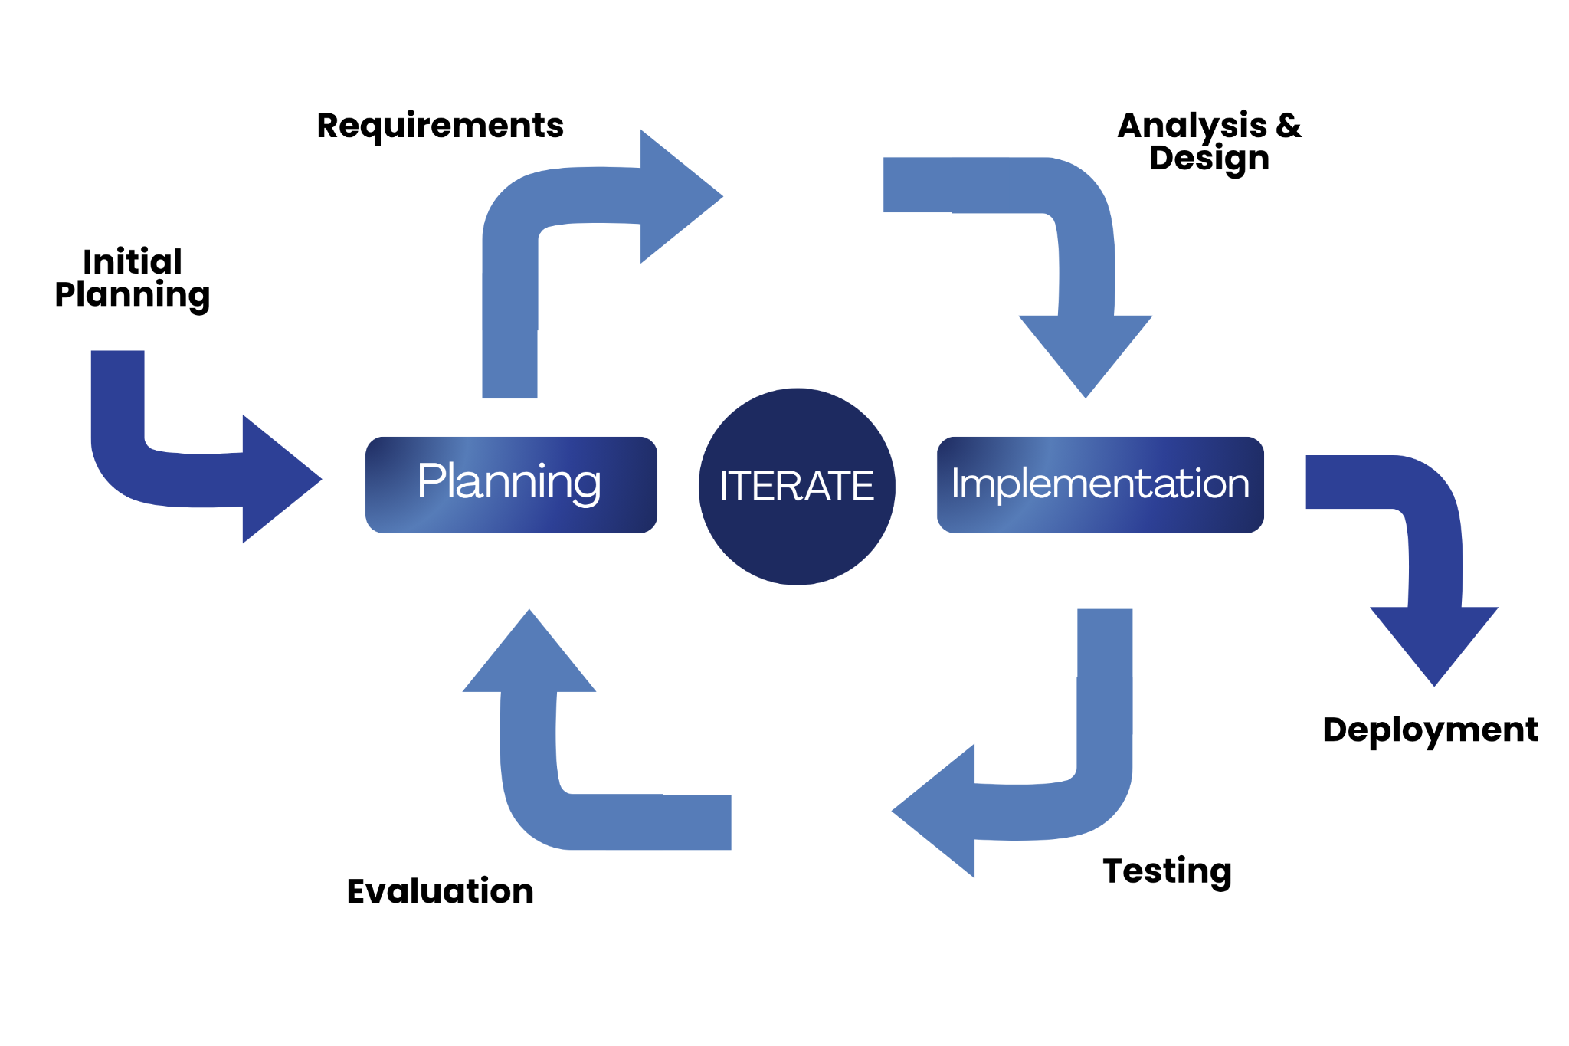
Figure 3.1
Agile Software Development Life Cycle Model

Phase 1: Requirements Planning
During the initial phase of project planning, the researcher listed the key requirements and identified possible challenges. They also prepared proactive solutions to handle these challenges during the development process.
The requirements planning phase began with consultations at Governor Mariano Villafuerte Community College, where the researcher engaged with the program head, instructors, students, and the identified client. Through these discussions, the researcher identified the school’s pressing challenges, particularly in inefficiencies such as delays in retrieving materials, inconsistencies in course content distribution, and limited opportunities for interactive learning. These issues hindered effective teaching and learning, consumed significant time and resources, and prevented timely identification of struggling students.
Teachers emphasized the need for a centralized system that would allow them to record in grading sheets, accommodating both automatically checked online quizzes and manual recorded assessments, while also monitoring student performance in one platform. Students expressed the importance of consistent access to learning materials and support mechanisms that could help them comprehend lessons more effectively. Administrators highlighted insights into institutional policies and performance monitoring needs. These consultations established the foundation for the LearnSync project, ensuring that the system’s design directly responds to the school’s needs.
From these the functional requirements were defined teachers must be able to upload text-based materials, create quizzes, assign activities, and record scores, while students should access these resources and interact with an AI assistant that provides summaries, guided explanations, and adaptive feedback strictly from teacher-uploaded content. Accuracy of AI responses, and ease of use for both teachers and students.
Figure 3.1 show as the hardware requirements to successfully implemented and utilized the system. Computer hardware refers to the physical components that make up a computer system and enable it to perform essential functions, such as input, output, processing and storage. Susnja and Smalley (2026).
Table 3.1
Hardware Requirements for LearnSync: A Cloud-Based AI Academic Assistant for Student Performance Development
Hardware Requirements
Hardware | Minimum | Recommended
Processor | At least Dual Core processor | Core i3 and above, latest generation processor
RAM | 8GB | 16 GB or more
Storage | 128 GB SSD | 256 GB SSD or higher
The processor, RAM, and storage each play a distinct role in supporting the system’s performance. The processor acts as the central unit that enables the learning management platform and the AI academic assistant to run smoothly. While a Celeron processor can handle basic tasks such as uploading modules and accessing files, a Core i3 or higher is recommended to efficiently process AI assistant, generate summaries, and provide adaptive feedback without delays. RAM, on the other hand, ensures responsiveness and multitasking capabilities. With multiple students and teachers accessing the system simultaneously through the LAN, a minimum of 8 GB allows basic functionality, but 16 GB or more is necessary to prevent lags and ensure real-time performance when handling quizzes, modules, and AI responses.
Storage capacity is equally critical, as it houses lesson modules, quizzes, student records, and AI training data. An SSD provides faster file access compared to traditional HDDs, ensuring quick retrieval of instructional materials. While 128 GB is sufficient for initial deployment, 256 GB or higher is recommended to accommodate scalability, supporting larger datasets, more subjects, and future expansion of the system. Altogether, these hardware requirements guarantee that LearnSync can function as a lightweight, AI-powered learning management system tailored to low-resource environments. Meeting the minimum specifications ensures usability, while the recommended specifications provide sustainability and scalability, aligning with the project’s goal of bridging digital divides and enhancing teaching and learning.
Table 3.2
Software Requirements for LearnSync: A Cloud-Based AI Academic Assistant for Student Performance Development
Software Requirements
Software | Minimum | Recommended
Operating System | Windows 10/Android 10 | Windows 11/android 10 and above
Internet | 2Mbps and above
Language | Python, html, CSS, JS
Database | PostgeSQL
Table 3.2 Software requirements needed to ensure compatibility and run the system efficiently and effectively. software, instructions that tell a computer what to do. Software comprises the entire set of programs, procedures, and routines associated with the operation of a computer system. Britannica (2026).
The system design to ensure compatibility and efficient operation, the system requires specific software components. At minimum, the operating system should be Windows 11 or Android 10 and above, with the latest stable release recommended for enhanced security and performance. The system must function with internet access required, though a stable mobile data or broadband connection is advisable for smoother data transfer and real-time interactions. The programming languages used in development include Python, HTML, CSS, and JavaScript, and it is recommended to utilize updated versions of these languages to maintain compatibility with modern frameworks and libraries. For data management, PostgreSQL serves as the database system, providing reliable storage and retrieval of information, and more strict security and structure with the latest stable release recommended to ensure optimal performance and security. Overall, these software requirements are essential to guarantee that the system runs effectively, supports scalability, and delivers a seamless user experience.
. The researcher developed a Gantt chart, presented as Figure 3.2, to serve as a guide for project implementation. This chart highlighted the key milestones necessary to ensure that tasks were completed within the designated timeframe and that the overall project advanced according to the deadlines set by the researcher.

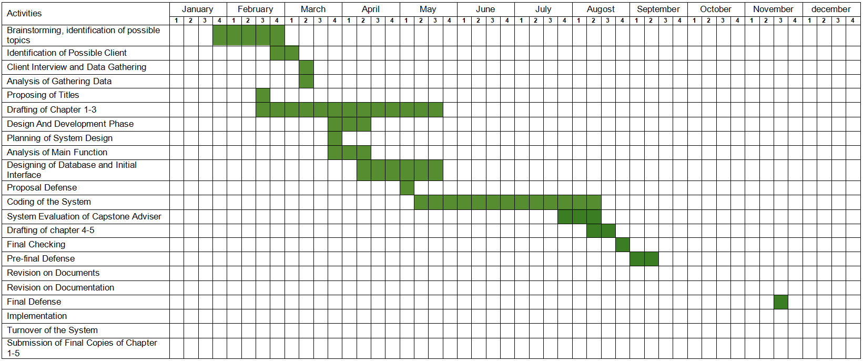
Figure 3.2
Gantt Chart of the Development of “Learnsync: A Cloud-Based AI Academic Assistant for Student Performance Development”

Phase 2: User Design
The user design phase focuses on creating a practical and user-friendly interface by involving end-users in the design process. Researchers and developers collaborate to identify user needs, workflows, and preferences, ensuring the system is intuitive and efficient. This stage often includes prototypes, wireframes, and mock-ups that allow users to visualize the system and provide feedback before full development. By engaging users early, potential issues can be addressed, resulting in a final product that is accessible, reliable, and aligned with its intended tasks.
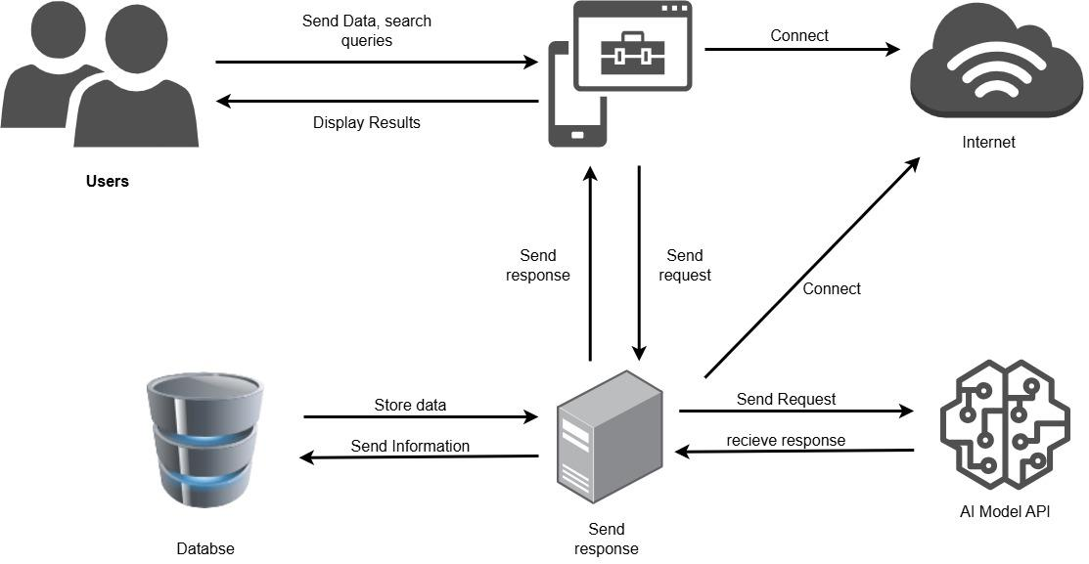
Figure 3.3
LEARNSYNC: A Cloud-Based AI Academic Assistant for Student Performance Development
Figure 3.3 illustrates the core architecture of the Learnsync: A Cloud-Based AI Academic Assistant for Student Performance Development. It highlights the main components involved in the interaction between the user and the system, including the devices, web system platform, server, database.
The process begins when the user (student or teacher) accesses the system through various devices such as smartphones, tablets, or desktop computers. These devices act as the interface, allowing students to interact with lessons, quizzes. Teachers use the same interface to upload content, record scores and grades, and monitor student progress. The client devices connect to the system via web browsers. They handle user inputs such as activities submissions, quiz answers, and AI assistant queries. These inputs are packaged into requests and sent to the server for processing.
The server acts as the central processing unit of the system. It receives requests from client devices, processes the application logic checking quiz answers, running AI generation, and manages communication between the user interface and the database. In LearnSync, the server also hosts the AI academic assistant, which provides adaptive feedback, guided explanations, and performance monitoring. While the database stores all persistent information, including user profiles, lesson modules, activity submissions, progress tracking, and quiz results. It communicates with the server to retrieve and update data in real time, ensuring accuracy and availability across the system. For LearnSync, this centralized database eliminates fragmented records and combines both online and offline scores in one platform, making grades and compilation of activities and assessments available for teacher in one place, and for the awareness of students.
This guide shows how the system flows user’s client devices server database back to users. Each component plays a vital role in ensuring smooth interaction, centralized resource management, and efficient learning delivery. This architecture is adapted to a cloud-based system, directly addressing GMVCC’s learning challenges while still providing modern AI-driven educational support.
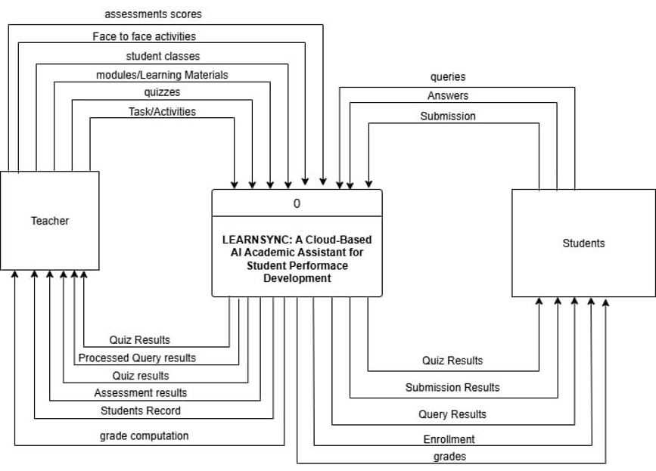
Figure 3.4
Context Diagram of Learnsync: A Cloud-Based AI Academic Assistant for Student Performance Development
Figure 3.4 illustrates the Context Diagram of LearnSync, showing the overall interaction between the system and its two main external entities, the Teacher and Students. The diagram presents the major data exchanged between the users and the system, including learning materials, assessments, submissions, queries, results, grades, and student records.

The Teacher provides the system with student classes, modules/learning materials, quizzes, tasks/activities, face-to-face activities, and assessment scores. These data are processed by LearnSync to support the teacher in managing learning materials, assessments, and student performance. The system then provides the teacher with quiz results, processed query results, assessment results, student records, and grade computation, allowing the teacher to monitor and manage student academic performance.
The Students interact with LearnSync by sending queries, answers, submissions, and enrollment information to the system. Students can use the system to access learning activities, answer quizzes, submit their work, and send queries to the AI academic assistant. The system processes these inputs and provides the students with quiz results, submission results, query results, enrollment information, and grades.
Overall, the Context Diagram shows that LearnSync serves as the central platform connecting teachers and students. It receives instructional and assessment data from teachers and student-related inputs from students, processes these data, and provides the appropriate results and information to both users. This supports the management of learning materials, assessment activities, AI-assisted queries, enrollment, and student performance monitoring.

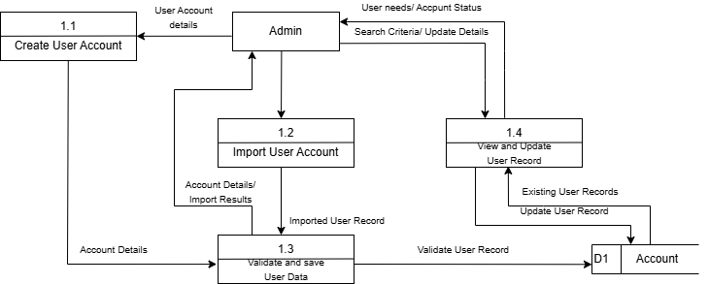
Figure 3.5
Data Flow Diagram for Admin
Figure 3.5 illustrates the Data Flow Diagram (DFD) of the Admin Module of LEARNSYNC: A Cloud-Based AI Academic Assistant for Student Performance Development. It shows how the administrator manages user accounts, validates account information, imports user records, and views or updates existing user records. The diagram also shows how account data is stored and retrieved from the Account (D1) data store.
The process starts with Create User Account (1.1), where the Admin provides the necessary user account details. The account details are then passed to Validate and Save User Data (1.3), where the information is checked and saved. The validated user record is then stored in the Account (D1) data store to maintain the user's account information.
The Admin can also use Import User Account (1.2) to bring existing user account information into the system. The process receives the account details from the Admin and produces an import result and an imported user record. The imported record is then passed to Validate and Save User Data (1.3) for validation before being stored in the Account (D1) data store.
Lastly, View and Update User Record (1.4) allows the Admin to manage existing user information. The Admin provides search criteria or update details, while the process retrieves existing user records from Account (D1). After the necessary changes are made, the updated user record is returned to the data store. The process also provides the Admin with information about user needs or account status.
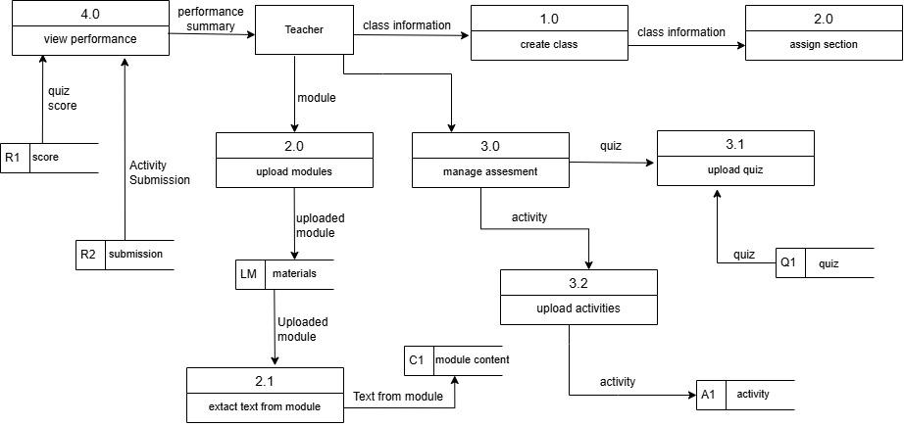
Figure 3.6
Data Flow Diagram for Teacher

Figure 3.5 illustrates the Data Flow Diagram (DFD) of the Teacher Module, showing how data moves within the system and how the teacher interacts with different processes and data elements. The diagram presents the core instructional and administrative functionalities of the module, beginning with class creation and section assignment, followed by the uploading of modules, management of assessments, and monitoring of student performance.
The process starts with Create Class (1.0), where the teacher establishes a new class to organize students and learning materials. Once the class is created, the teacher proceeds to Assign Section (2.0), grouping students into appropriate sections for better management. After sections are assigned, the teacher can Upload Modules (2.0), which serve as the primary learning materials (LM). Within this process, the system can also Extract Text from Module (2.1), converting module content (C1) into usable formats for for retrieval of data by AI Assistant.
The next major function is Manage Assessment (3.0), where the teacher oversees different evaluation tools. This includes Upload Module (3.1) for assessment-linked materials, Upload Activities (3.2) for student tasks (Act1), and the creation of quizzes (Q1) to measure student understanding. These assessment components ensure that students are continuously evaluated through structured activities and quizzes.
Lastly, the teacher can View Performance (4.0), which consolidates student outcomes. This process retrieves Scores (R1) from quizzes and activities, as well as Submissions (R2) from student work. By analyzing these results, the teacher gains insights into student progress, engagement, andoverall performance.
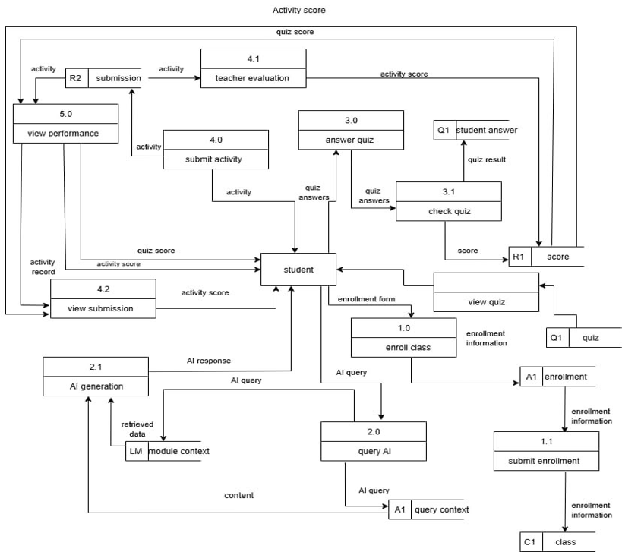
Figure 3.7
Data Flow Diagram for Student

Figure 3.6 illustrates the Data Flow Diagram (DFD) of the Student Module, showing how data moves within the system and how the student interacts with different processes and data elements. The diagram presents the main functions of the module, including class enrollment, viewing quizzes, answering assessments, submitting activities, interacting with the AI Assistant, and monitoring academic performance.
The process starts with Enroll Class (1.0), where the student provides the necessary enrollment information to join a class. The enrollment information is passed to Submit Enrollment (1.1), where the enrollment details are processed and stored in A1 (Enrollment). The student can also access View Quiz, which retrieves available quizzes from Q1 (Quiz) for the student to answer.
The next major function is Answer Quiz (3.0), where the student answers the assigned quiz. The quiz answers are passed to Check Quiz (3.1), where the answers are evaluated and a quiz result is produced. The resulting score is stored in R1 (Score). The student can also Submit Activity (4.0), where completed activities are submitted and stored in R2 (Submission). These submissions can be reviewed through Teacher Evaluation (4.1), where the teacher evaluates the student's activity and provides an activity score.
The student can also use the AI Assistant through Query AI (2.0). In this process, the student sends an AI query, which is passed to AI Generation (2.1). The AI Generation process retrieves relevant information from the Materials (LM) data store and uses the module context to generate an AI response. This allows the student to receive assistance based on the available learning materials.
Lastly, the student can access View Performance (5.0) to monitor academic results. This process receives quiz scores and activity scores, as well as activity submissions, to provide information about the student's performance. The student can also use View Submission (4.2) to view submitted activities and their corresponding results. Overall, the DFD shows how LearnSync allows students to enroll in classes, access learning materials and assessments, submit activities, receive AI-assisted support, and monitor their academic performance.

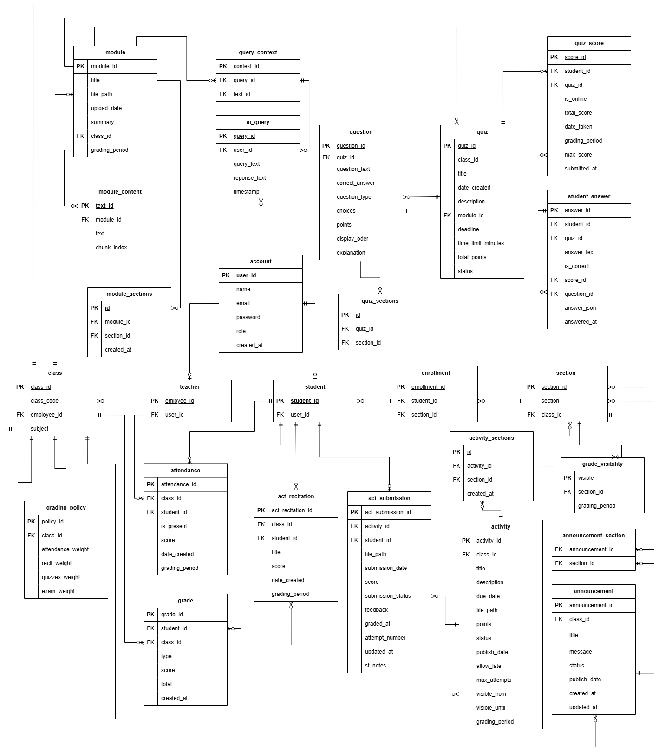
Figure 3.8

Entity Relationship Diagram of “LEARNSYNC: A Cloud-Based AI Academic Assistant for Student Performance Development”

Figure 3.7 illustrates the Entity Relationship Diagram (ERD) of LEARNSYNC: A Cloud-Based AI Academic Assistant for Student Performance Development. The ERD presents the organization and relationships of the database entities designed by the researchers to support user management, class organization, learning materials, assessments, student submissions, grading, announcements, and AI-assisted academic support.
At the center of the database structure is the account entity, which stores essential user information such as user ID, name, email, password, role, and account creation date. The researchers connected this entity to the teacher and student entities to properly identify and manage the different users of LearnSync. Teachers are associated with classes, while students are connected to classes and sections through enrollment.
The academic structure designed by the researchers is represented by the class, section, enrollment, and grading_policy entities. The class entity stores information about the class, subject, and assigned teacher, while the section entity organizes students according to their assigned sections. The enrollment entity connects students to their sections. The grading_policy entity stores the grading weights used for different assessment components.
For learning materials, the researchers included the module, module_content, and module_sections entities. The module entity stores information about uploaded learning materials, while module_content stores the extracted text and corresponding content chunks. The module_sections entity connects learning modules to specific sections. This structure allows the researchers to organize the instructional materials that will be used within the LearnSync platform.
Learning activities and assessments are represented by the activity, activity_sections, act_submission, quiz, question, quiz_sections, student_answer, and quiz_score entities. The researchers designed the activity entity to store assignments and tasks, while act_submission records student submissions, scores, feedback, and submission status. The quiz entity stores assessment information and is connected to the question entity, which contains questions, choices, correct answers, points, and explanations. Student responses are recorded through the student_answer entity, while quiz results are stored in quiz_score.
To support student performance monitoring, the researchers included the attendance, act_recitation, and grade entities. Attendance records student presence and related scores, while act_recitation stores recitation results. The grade entity stores student performance information, including scores and totals. These entities allow the researchers to organize different assessment records and provide the necessary data for monitoring student performance.
The researchers also included the announcement and announcement_section entities to support academic communication. The announcement entity stores information such as the title, message, publication date, and status, while announcement_section associates announcements with specific sections. This allows relevant announcements to be organized according to the students or sections concerned.
For the AI Academic Assistant, the researchers incorporated the ai_query and query_context entities. The ai_query entity stores the user's AI questions, responses, and timestamps, while the query_context entity connects queries with relevant module_content. This structure supports the researchers' design of an AI assistant that can use teacher-uploaded instructional materials as context when providing academic assistance. This is consistent with the scope of the study, which states that the AI assistant generates responses based on teacher-uploaded modules.
Overall, the ERD demonstrates how the researchers structured and interconnected the database entities of LearnSync to support its major functions. Accounts and users manage system access, classes and enrollment organize academic participation, modules and activities provide learning content, quizzes and assessments measure student performance, grades and records support performance monitoring, and AI queries and query context provide academic assistance. Through these relationships, the researchers established the database structure needed to support teaching, assessment, academic assistance, and student performance development within LearnSync.

NOTES
Liyanage, N. (2025). The Agile Model in SDLC: A Flexible Approach to Software Development. https://medium.com/@nld.anuradha/the-agile-model-in-sdlc-a-flexible-approach-to-software-development-664bf60ad9dc

GeeksforGeeks. (2024). Iterative incremental model in designing system. https://www.geeksforgeeks.org/system-design/iterative-incremental-model-in-designing-system/

